IL Auto Line of Business
Required Fields to quote are in yellow and all other fields are optional…see screen shots for example.
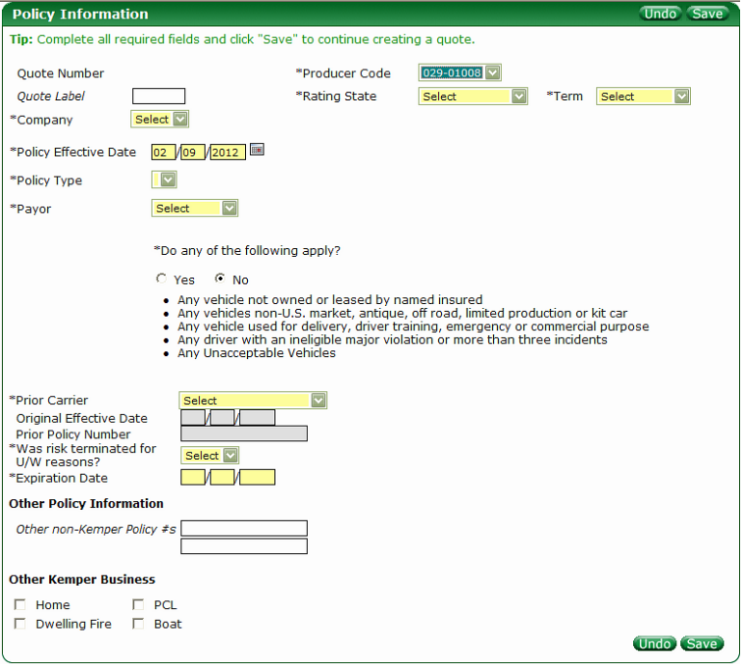
Required Fields to quote are in yellow and all other fields are optional. Note: the Original Effective Date and Prior Policy Number are required if the criteria for those fields are met.
- Producer Code (dropdown) – You will not provide
  - List of all Producer Codes linked to the login ID.
- Quote Label (freeform field)
  - An optional field to label a quote for downloads search capability.
- Rating State (dropdown) - You will provide
  - Currently a list of states where Kemper writes Business
- Term (dropdown) – You will provide
  - Semi-annual
  - Annual
- Company (dropdown) - You will provide - Filter by State
  - Displays options after State is selected
- Policy Effective Date (freeform field)
  - Currently defaults to current date but can be modified
- Policy Type (dropdown) – You will provide - Policy Type – Filter by State
  - Displays options after State is selected (I.e. Split & Single)
- Payor (dropdown) – You will provide
- Do any of the following apply? (Radio button)
  - Yes/No options
    - If Yes then the user cannot quote RPW
- “Do any of the following apply?” – You will provide
  - Policy Information Questions – Filter by LOB then by State
  - These questions are different by Line of Business and can vary by State
- Prior Carrier (dropdown) – You will provide
  - List of insurance carriers & also used to denote Rewrites if a “Kemper” Company is selected
    - If a Kemper Company is selected then the Original Effective Date and Prior Policy Number fields open up for entry.
- Original Effective Date (freeform field)
  - Only available (becomes enabled )when a Kemper Company is selected for Prior Carrier (Rewrites)
- Prior Policy Number (freeform field)
  - Only available (becomes enabled) when a Kemper Company is selected for Prior Carrier (Rewrites)
- Was risk terminated for U/W reasons? (dropdown) – You will Provide
  - Yes/No options
- Expiration (freeform field)
  - This is auto populated with current date after Prior Carrier is selected but can be modified
- Other Policy Information (freeform field)
- Other Kemper Business (checkboxes)
  - Denotes other Lines of Business for the user
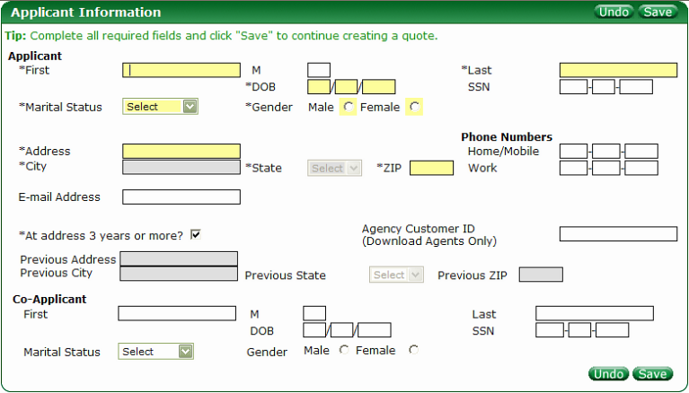

Applicant
- First (freeform field)
- M (freeform field)
- Last (freeform field)
- DOB (freeform field)
- SSN (freeform field)
- Marital Status (dropdown) – You will provide
- Gender (radio buttons)
  - Male/Female
- Address (freeform field)
- City (freeform field)
  - Auto populated but Location Service look-up when Zip is entered
  - If no information returned from Location Service or bad data entered this field becomes enabled
- State (dropdown) – You will provide
  - Auto populated but Location Service look-up when Zip is entered
  - If no information returned from Location Service or bad data entered this dropdown becomes enabled
- Zip (freeform field)
  - Drives Location Service lookup
- Home/Mobile (freeform field)
- Work (freeform field)
- Email (freeform field)
- At address 3 years or more? (checkbox)
  - Default is to have this checked
  - If checked then previous address information remains disabled. If unchecked then previous address information becomes enabled.
- Agency Customer ID (freeform field)
- Previous Address (freeform field)
  - See “At address 3 years or more?” information
- Previous City (freeform field)
  - See “At address 3 years or more?” information
  - Auto populated but Location Service look-up when Zip is entered
  - If no information returned from Location Service or bad data entered this field becomes enabled
- Previous State (dropdown) You will provide
  - See “At address 3 years or more?” information
  - Auto populated but Location Service look-up when Zip is entered
  - If no information returned from Location Service or bad data entered this dropdown becomes enabled
- Previous Zip (freeform field)
  - See “At address 3 years or more?” information
  - Drives Location Service lookup
Co-Applicant
- First (freeform field)
- M (freeform field)
- Last (freeform field)
- DOB (freeform field)
- SSN (freeform field)
- Marital Status (dropdown) – You will provide
- Gender (freeform field)

Vehicles – Limited number of Vehicles allowed
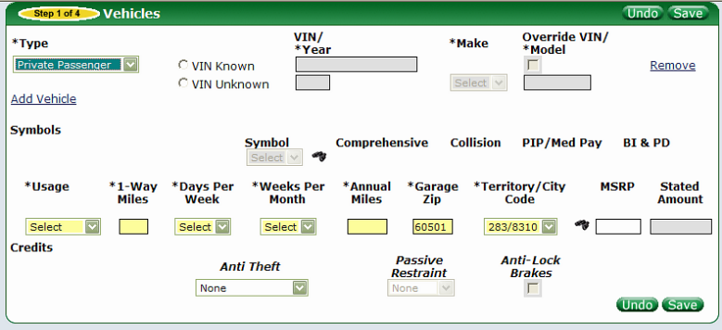

- Type Field (dropdown) –You will provide – Filter by Line of Business, State & Company
- Vin Know/Vin Unknown (radio buttons)
- Vin/*Year (freeform field)
  - Vin Known selected then ability to key in Vin is open
    - If Vin not found then user must re-enter or use Override Vin option (see below)
  - Vin Unknown selected then the below items become enabled:
    - Year (freeform field)
    - Make (dropdown) – You will provide
    - Model (freeform field)
- Override Vin (checkbox)
  - Enabled if Vin Service cannot return information (invalid/not found Vin)
  - Auto checked for Recreational vehicles
Symbols: Filter by Line of Business, State & Company
- Symbol (dropdown) – You will provide
  - Populated by Vin Service or default value based on the Overridden Vin
- Comprehensive (dropdown) – You will provide
  - Populated by Vin Service or default value based on the Overridden Vin
  - 2011 Vehicles or greater for value
- Collision (dropdown) – You will provide
  - Populated by Vin Service or default value based on the Overridden Vin
  - 2011 Vehicles or greater for value
- PIP/Med Pay (dropdown) – You will provide
  - Populated by Vin Service or default value based on the Overridden Vin
- BI & PD (dropdown) – You will provide
  - Populated by Vin Service or default value based on the Overridden Vin
- Usage (dropdown) - You will provide
- 1-Way Miles (freeform field)
  - Enabled when “Commute” is selected from Usage dropdown
- Days Per Week (dropdown) – You will provide
  - Enabled when “Commute” is selected from Usage dropdown
- Weeks Per Month (dropdown) – You will provide
  - Enabled when “Commute” is selected from Usage dropdown
- Annual Miles (freeform field)
- Garage Zip (freeform field)
  - Call to Location Service based on this field
- Territory/City Code (dropdown) – You will provide
  - Populated based on the response from Location Service based on Garage Zip field
- Binocular Icon (see screen shot below)
  - “Check here to skip territory locator and manually enter the territory (checkbox)
    - If checked it disables Zip Code and City Name fields but enables Rating Territory and City Code fields
  - Zip Code (freeform)
    - Auto populates with Garage Zip
    - Disabled
  - City Name (freeform)
    - Auto populates with City Name
    - Enabled unless the manually enter the territory checkbox is checked
  - Territory/City Code (dropdown) – You will provide
  - City Description (freeform)
  - Rating Territory (freeform)
    - Auto populated with Territory value
    - Disabled unless manually enter the territory checkbox is checked
    - If modified this will overwrite the Territory on the Vehicles Tile
  - City Code (freeform)
    - Auto populated with City Cod value
    - Disabled unless manually enter the territory checkbox is checked
    - If modified this will overwrite the City Code on the Vehicles Tile
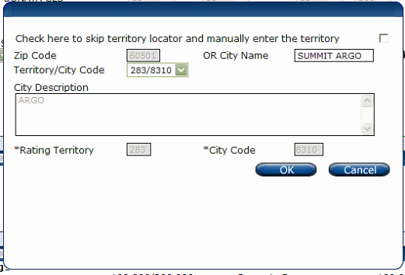
- MSRP (freeform field)
  - Populated by user or Vin Service
  - Disabled for Recreational vehicles
- Stated Amount (freeform field)
  - Enabled for Recreational vehicles
- Anti Theft (dropdown) – You will provide
  - Populated by Vin Service or user when Vin is overridden
  - Enabled with Vin override
- Passive Restraint (dropdown) – You will provide
  - Populated by Vin Service or user when Vin is overridden
  - Enabled with Vin override
- Anti-Lock Brakes (checkbox)
  - Populated by Vin Service or user when Vin is overridden
  - Enabled with Vin override

Drivers – Limited amount of Drivers allowed
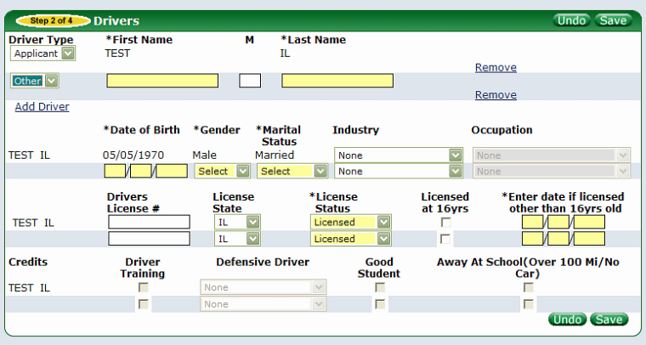

- Driver Type (dropdown) – You will provide
  - For Applicant & Co-Applicant (if applicable) is automatically brought down from the Applicant Tile
- First Name (freeform field)
  - For Applicant & Co-Applicant (if applicable) is automatically brought down from the Applicant Tile
- M (freeform field)
  - For Applicant & Co-Applicant (if applicable) is automatically brought down from the Applicant Tile
- Last Name (freeform field)
  - For Applicant & Co-Applicant (if applicable) is automatically brought down from the Applicant Tile
- Date of Birth (freeform field)
  - For Applicant & Co-Applicant (if applicable) is automatically brought down from the Applicant Tile
- Gender (dropdown) – You will provide
  - For Applicant & Co-Applicant (if applicable) is automatically brought down from the Applicant Tile
- Marital Status (dropdown) – You will provide
  - For Applicant & Co-Applicant (if applicable) is automatically brought down from the Applicant Tile
- Industry (dropdown) – You will provide
  - Drives the display for the Occupation
- Occupation (dropdown) – You will provide
  - This field is available after the selection for Industry is made.
  - Filtered by Industry
- Drivers License # (freeform field)
  - State specific format is required
- License State (dropdown) – You will provide
  - Defaults to Rating state but can be changed
- License Status (dropdown) – You will provide
  - Defaults to Licensed but can be changed
- Licensed at 16 yrs (checkbox)
  - If selected the system adds 16 years to the Date of Birth
- Enter date if licensed other than 16 yrs old (freeform field)
  - Auto populates if Licensed at 16 yrs is checked
Credits: Filter by Line of Business, State & Company
- Driver Training (checkbox)
  - Available based on age of driver (I.e. 16-24 years old)
- Defensive Driver (dropdown) – You will provide
  - Availability based age and state factors
- Good Student (checkbox)
  - Available based on age
- Away at School (Over 100 Mi/No Car) (checkbox)
  - Available based on age

Auto Policy Coverages & Discounts
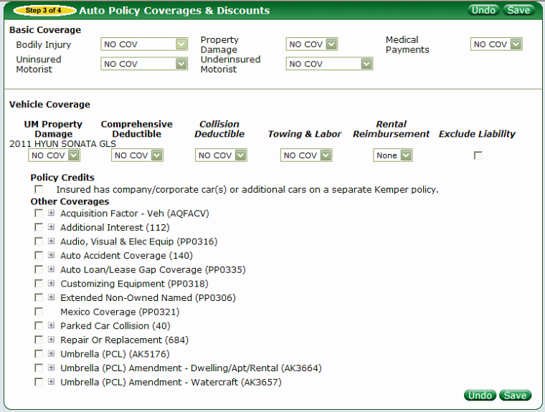
Note: Rules can exist around the below coverages and endorsements (I.e. Uninsured Motorist must equal Underinsured Motorist Coverage). Also Coverages have a filter by Line of Business, State & Company
- Bodily Injury (dropdown) – You will provide
- Property Damage (dropdown) – You will provide
- Medical Payments (dropdown) – You will provide
- Uninsured Motorist (dropdown) – You will provide
- Underinsured Motorist (dropdown) – You will provide
- UM Property Damage (dropdown) – You will provide
- Comprehensive Deductible (dropdown) – You will provide
- Collision Deductible (dropdown) – You will provide
- Towing & Labor (dropdown) – You will provide
- Rental Reimbursement (dropdown) – You will provide
- Exclude Liability (checkbox)
  - This checkbox will exclude all Basic Coverage (BI, PD, Med Pay, UM & UIM coverages listed above)
- Policy Credits (If applicable) (checkbox) – Filter on Line of Business, State, Company & Policy Type (Mono-line or Package)
  - Available options will display if criteria is met

Other Coverages - Endorsements
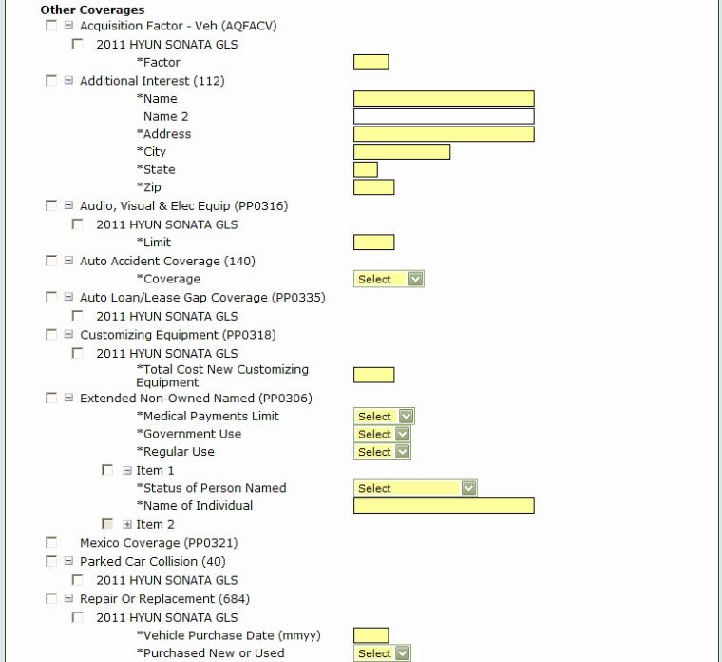
- Other Coverages (all options are checkboxes) – You will provide – Filter by Line of Business, State, Company & Policy Type (Mono-line or Package)
  - Examples of endorsements for Auto Line of Business
    - Acquisition Factor – Veh (AQFACV)
      - Freeform field when selected
    - Additional Interest (112)
      - Freeform fields when selected
    - Audio, Visual & Elec Equip (PP0316)
      - Freeform field when selected
    - Auto Accident Coverage (140)
      - Dropdown for “Coverage” when selected – You will provide
    - Auto Loan/Lease Gap Coverage (PP0335)
      - Checkbox when selected
    - Customizing Equipment (PP0318)
      - Checkbox when selected for each applicable vehicle and a freeform field for each vehicle
    - Extended Non-Owned Named (PP0306)
      - Dropdowns for Medical Payments Limit, Government Use & Regular Use – You will provide
      - Checkbox for Item
        - When Item selected a dropdown for Status of Person Named – You will provide
        - Freeform for Name of Individual
    - Mexico Coverage (PP0321)
    - Parked Car Collision (40)
      - Checkbox when selected
    - Repair Or Replacement (684)
      - Checkbox for each vehicle
      - Freeform for Vehicle Purchase Date (mmyy)
      - Dropdown for Purchased New or Used – You will provide
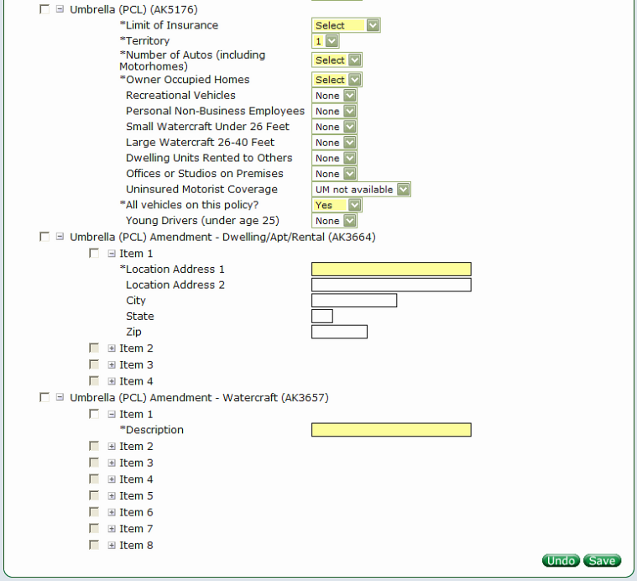

- Umbrella (PCL) (AK5176)
  - Dropdowns for fields – You will provide
    - Limit of Insurance
    - Territory
      - Populated based on Garage Zip
    - Number of Autos (including Motorhomes)
    - Owner Occupied Homes
    - Recreational Vehicles
    - Personal Non-Business Employees
    - Small Watercraft Under 26 Feet
    - Large Watercraft 26-40 Feet
    - Dwelling Units Rented to Others
    - Offices or Studios on Premises
    - Uninsured Motorist Coverage
    - All vehicles on this Policy?
    - Young Drivers (Under age 25)
      - Rules surround this and all Drivers age
- Umbrella (PCL) Amendment – Dwelling/Apt/Rental (AK3664)
  - Required if Dwelling Units Rented to Others in Umbrella (PCL) has a value
  - Checkbox for each item
  - Freeform fields
    - Location Address 1
    - Location Address 2
    - City
    - State
    - Zip
- Umbrella (PCL) Amendment – Watercraft (AK3657)
  - Required if Small Watercraft Under 26 Feet and/or Large Watercraft 26-40 Feet in Umbrella (PCL) has a value
  - Checkbox for each item
  - Freeform field for Description
Vehicle/Driver Assignments Tile
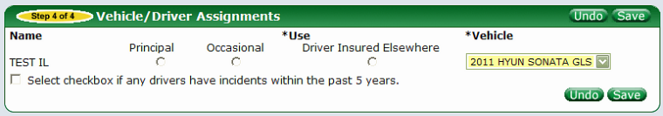

- Name
  - Auto populated from Drivers Tile for each Driver
- Principal (radio button)
- Occasional (radio button)
- Driver Insured Elsewhere (radio button)
  - When selected this disables the Vehicle dropdown
- Vehicle (dropdown) – You will provide
  - List of all Private Passenger vehicles on the quote/policy
- Select checkbox if any drivers have incidents within the past 5 years (checkbox)
  - When selected system currently brings the user to the Incidents Tile.

Incidents Tile
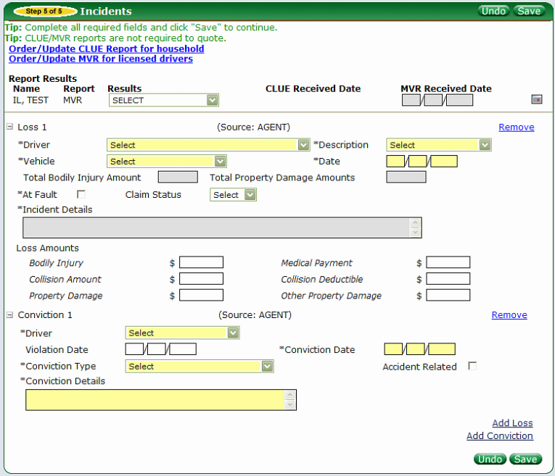
Note: If the Link(s) are selected then a call to Lexus Nexus is made for the appropriate report. “Order/Update CLUE Report for household” and “Order/Update MVR for licensed drivers”
- Report Name
  - Auto populated for each Driver
- Report
  - Type of Report is displayed
- Results (dropdown) – You will provide
  - Auto populated for a valid call to Lexus Nexus (Choicepoint)
  - Available for user selection for invalid call to Lexus Nexus
- CLUE Received Date (freeform field)
  - Auto populated with Date report received
  - Available for user entry for invalid call to Lexus Nexus
- MVR Received Date(freeform field)
  - Auto populated with Date report received
  - Available for user entry for invalid call to Lexus Nexus
- Loss(es)
  - Driver (dropdown) – You will provide
    - Auto populated for valid calls to Lexus Nexus
    - User can select on manual entry (Agent entered)
  - Description (dropdown) - You will provide
    - Auto populated for valid calls to Lexus Nexus
    - User can select on manual entry (Agent entered)
  - Vehicle (dropdown) - You will provide
    - User can select
  - Date (freeform)
    - Auto populated for valid calls to Lexus Nexus
    - User can enter (Agent entered)
  - Total Bodily Injury Amount (freeform)
    - Auto populated for valid calls to Lexus Nexus
    - Auto populated for Agent Entered loss when “Bodily Injury” in Loss Amounts section is entered
  - Total Property Damage Amounts (freeform)
    - Auto populated for valid calls to Lexus Nexus
    - Auto populated for Agent Entered loss when “Property Damage” & “Other Property Damage” in Loss Amounts section is entered (adds the 2 fields together)
  - At Fault (checkbox)
    - Auto checks when Bodily Injury, Collision Amount, Property Damage & Other Property Damage in Loss Amount section is present
    - Is editable for user to select/unselect
  - Loss Amounts
    - Freeform fields
      - Bodily Injury
      - Medical Payment
      - Collision Amount
      - Collision Deductible
      - Property Damage
      - Other Property Damage
- Conviction(s)
  - Driver (dropdown) – You will provide
    - Auto populated on valid calls to Lexus Nexus
    - User can select on manual entry (Agent entered)
  - Violation Date (freeform)
    - Auto populated on valid calls to Lexus Nexus
    - User can enter on manual entry (Agent entered)
  - Conviction Date (freeform)
    - Auto populated on valid calls to Lexus Nexus
    - User can enter on manual entry (Agent entered)
  - Conviction Type (dropdown) – You will provide
    - Auto populated on valid calls to Lexus Nexus
    - User can enter on manual entry (Agent entered)
  - Accident Related (checkbox)
  - Conviction Details
    - Auto populated on valid calls to Lexus Nexus
    - User can enter on manual entry (Agent entered)

Lienholder/Additional Lienholder Information
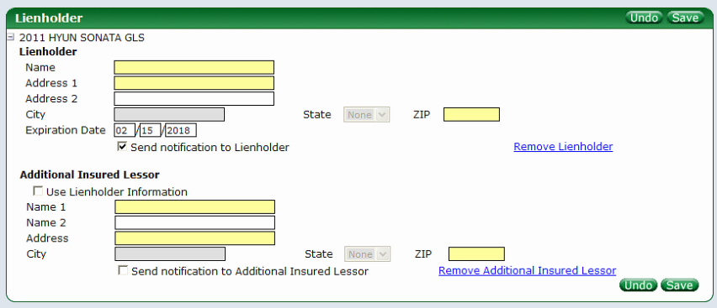

- Available for each Private Passenger vehicle
  - Name (freeform)
  - Address 1 (freeform)
  - Address 2 (freeform)
  - City
    - Auto populated based on Zip entered but if invalid/can’t find zip then available for manual entry
  - State (dropdown) – You will provide
    - Auto populated based on Zip entered but if invalid/can’t find zip then available for manual entry
  - Zip (freeform)
    - Triggers a call to Location Service
  - Send notification to Lienholder (checkbox)
- Use Lienholder Information
  - Brings Lienholder information and auto populates all fields
  - Name 1 (freeform)
  - Name 2 (freeform)
  - Address (freeform)
  - City
    - Auto populated based on Zip entered but if invalid/can’t find zip then available for manual entry
  - State (dropdown) – You will provide
    - Auto populated based on Zip entered but if invalid/can’t find zip then available for manual entry
  - Zip (freeform)
  - Triggers a call to Location Service

General Information and Notes
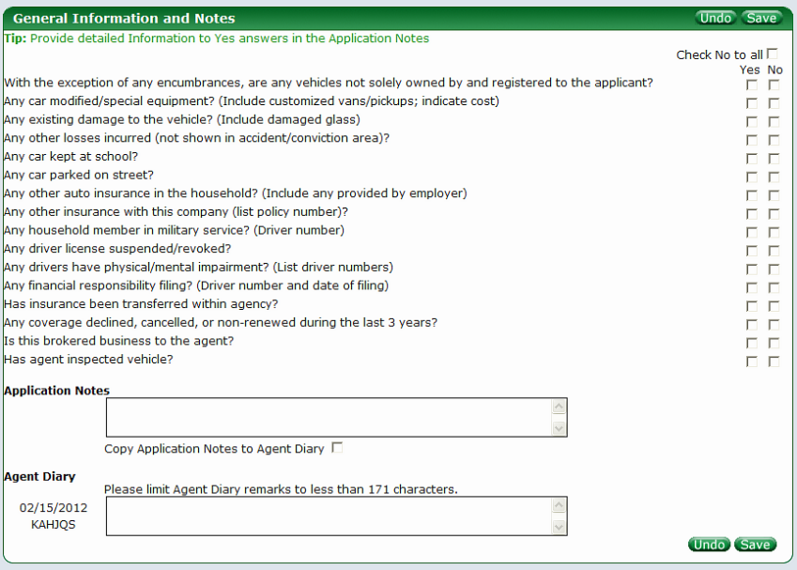

- Check No to all (checkbox)
  - Auto checks all checkboxes for the user
- Questions
  - Filter on LOB, State & Company
    - Will be different based on the above
  - All require a “Yes” or “No” checkbox to be selected
- Application Notes (freeform)
- Copy Application Notes to Agent Diary (checkbox)
  - Copies the Application Notes to the Agent Diary section
- Agent Diary (freeform)

Billing & Binding
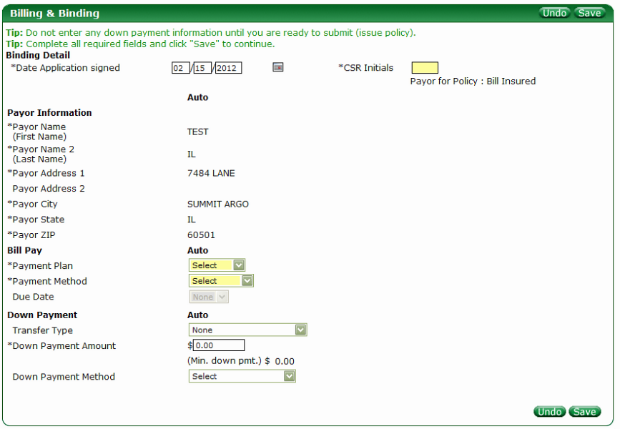

- Date Application signed (freeform)
  - Defaults to current date
- CSR Initials (freeform)
- Payor Information
  - If Payor on Policy Information Tile is “Bill Insured”
    - All Payor Information fields are auto populated with Applicant information from Applicant Tile and not editable
      - Payor Name (First Name)
      - Payor Name 2 (Last Name)
      - Payor Address 1
      - Payor Address 2
      - Payor City
      - Payor State
      - Payor Zip
  - If Payor on Policy Information Tile is “Bill Other”
      - All Payor Information fields will display for entry
      - Payor Name (First Name) – freeform
      - Payor Name 2 (Last Name) – freeform
      - Payor Address 1 – freeform
      - Payor Address 2 – freeform
      - Payor City
        - Auto populated if zip is found
        - Manual entry if zip is not found
      - Payor State – dropdown – You will provide
        - Auto populated if zip is found
        - Manual entry if zip is not found
      - Payor Zip – freeform
  - Payment Plan (dropdown) – You will provide
  - Payment Method (dropdown)– You will provide
    - If EFT is selected
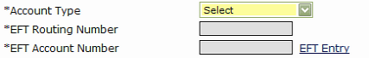
      - Due Date (dropdown) opens up
      - Account Type (dropdown) – You will provide
        - This field becomes available for selection
      - EFT Routing Number (freeform)
        - Disabled - EFT Entry link must be selected
      - EFT Account Number (freeform)
        - Disabled – EFT Entry link must be selected
      - EFT Entry link (link)
        - When select the below pop-up displays
          - EFT Routing Number (freeform)
            - Value returned to EFT Routing Number field and disabled
            - Value is hidden with “X”
          - Re-enter Routing Number (freeform)
          - EFT Account Number (freeform)
            - Value returned to EFT Account Number field and disabled
            - Value is hidden with “X”
          - Re-enter Account Number (freeform)
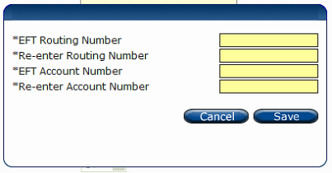

    - If MasterCard is selected

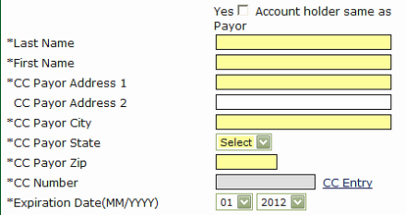

      - Yes Account holder same as Payor (checkbox)
        - Auto populates fields with Applicant Information from Applicant Tile
      - Last Name (freeform)
      - First Name (freeform)
      - CC Payor Address 1 (freeform)
      - CC Payor Address 2 (freeform)
      - CC Payor City (freeform)
      - CC Payor State (dropdown) – You will provide
      - CC Payor Zip (freeform)
      - CC Number (freeform)
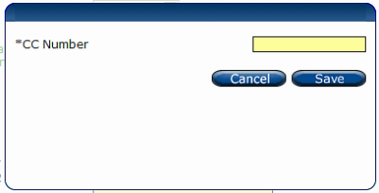
        - Disabled – must select CC Entry link
          - When selected a pop-up displays
            - CC Number (freeform)
            - Value entered is return to CC Number field and disabled
              - Value is hidden with “X”
      - Expiration Date (MM/YYYY) (dropdown) – You will provide
  - Transfer Type (dropdown) – You will provide
    - Filter by State
    - Selection can impact Down Payment required
  - Down Payment Amount (freeform)
    - (Min. down pmt.) $
      - Displays the minimum Down Payment required – You will provide
  - Down Payment Method (dropdown) – You will provide
    - Based on option selected
      - Same as Auto Bill Pay
        - Auto copies the Bill Pay information for Down Payment
      - MasterCard & Visa are the same as the Bill Pay fields listed above
      - eCheck
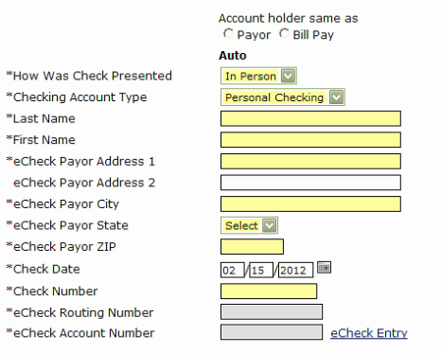
      - Account holder same as
        - Payor & Bill Pay (radio buttons)
          - Payor if selected auto copies Applicant Information from Applicant Tile
          - Bill Pay if selected auto copies Bill Pay information from Bill Pay section
      - How Was Check Presented (dropdown) – You will provide
      - Checking Account Type (dropdown) – You will provide
      - Last Name (freeform)
      - First Name (freeform)
      - eCheck Payor Address 1 (freeform)
      - eCheck Payor Address 2 (freeform)
      - eCheck Payor City (freeform)
      - eCheck Payor State (dropdown) – You will provide
      - eCheck Payor ZIP (freeform)
      - Check Date (freeform)
      - eCheck Routing Number (freeform)
        - Disabled – eCheck Entry link must be selected
      - eCheck Account Number (freeform)
        - Disabled – eCheck Entry link must be selected
      - When select the eCheck link the below pop-up displays
          - eCheck Routing Number (freeform)
            - Value returned to EFT Routing Number field and disabled
            - Value is hidden with “X”
          - Re-enter Routing Number (freeform)
          - eCheck Account Number (freeform)
            - Value returned to EFT Account Number field and disabled
            - Value is hidden with “X”
        - Re-enter Account Number (freeform)
